**Planning Proposal – Administrative Amendment – 3 Racecourse Road, Muswellbrook**

**PP_2020_MUSWE_001_00**

|  |  |  |
| --- | --- | --- |
| **Local Government Area:** | | Muswellbrook Shire Council (MSC) |
| **Name of Draft LEP:** | | Muswellbrook Local Environment Plan 2009 - PP_2020_MUSWE_001_00 |
| **Subject Land:** | | Lot 41 DP 592207 Muswellbrook. |
| **Land Owner:** | | Ms N Hall |
| **Applicant:** | | Casson Planning & Development Services |
| **Folder Number:** | | PP 017 |
| **Date:** | | 08 June 2020 |
| **Author:** | | David Casson & Sharon Pope |
| **Tables:** | Table No. | Details |
|  | 1 | Assessment of the Planning Proposal against relevant SEPPs |
|  | 2 | Consistency with applicable Ministerial Directions |
|  |  |  |
| **Maps:** | No. |  |
|  | 1 | Locality |
|  | 2 | Site Identification |
|  | 3 | Zoning |
|  | 4 | Minimum lot size |
|  | 5 | Extract from Hunter River Flood Study |
|  |  |  |

|  |  |  |
| --- | --- | --- |
| **Attachments:** | No. | Details |
|  | 1 | The Business Paper and Meeting Minutes of the 12 April 1977 Denman Ordinary Council Meeting. |
|  | 2 | Council letter dated 8 October 2019 advising that this land is not benefited by a ‘dwelling entitlement’. |
|  | 3 | Evaluation criteria for the delegation of plan making functions. |

**Part 1 – OBJECTIVES OR INTENDED OUTCOMES**

The objective of the Planning Proposal is to amend Muswellbrook Local Environmental Plan 2009 (MLEP 2009) in order to permit a dwelling house on Lot 41 DP 592207. It is intended to do this by Amending Schedule 1 – Additional Permitted Uses.

**Part 2 – EXPLANATION OF PROVISIONS**

The proposed objective will be achieved by amending the MLEP 2009 by: -

|  |  |
| --- | --- |
| **Amendment Applies to** | **Explanation of provision** |
| Clause 2.5 and Schedule 1 | To add the use of Lot 41 DP 592207 for a dwelling house as Item 4 in Schedule 1. |

**Part 3 – JUSTIFICATION**

**Section A – Need for the Planning Proposal**

1. ***Is the planning proposal a result of any strategic study or report?***

The planning proposal is not the result of a strategic study or report.

Lot 41 DP 592207 is zoned RU1 Primary Production under the Muswellbrook LEP 2009. In 2019 Council Officers determined that this land is not benefited by a ‘dwelling entitlement’ under the provisions of Clause 7.5 of the Muswellbrook LEP 2009. Correspondence regarding this matter is provided in Attachment C.

Staff undertook extensive research on the history of the lot. The Business Paper and Meeting Minutes of the 12 April 1977 Denman Ordinary Council Meeting refer to an application for the subdivision which created the lot. The Business Paper included a reference to use of each proposed lot in the subdivision being *‘for agricultural purposes in conjunction with a dwelling house’.* The business paper and meeting minutes are included as attachment 1.

Despite the subdivision proceeding, no dwelling house was constructed on Lot 41. Changes to planning legislation since 1977 has extinguishing any ‘dwelling entitlement’ for the land.

Muswellbrook LEP 2009 would need to be amended to reinstate a dwelling entitlement for this lot.

1. ***Is the planning proposal the best means of achieving the objectives or intended outcomes, or is there a better way?***

The land is zoned RU1 Primary Production and has an area of 6.07ha. A minimum lot size of 80ha applies to subdivision of this land.

A rural residential pattern of development already exists in the Racecourse Road locality. There are sixteen (16) RU1 Primary Production zoned lots with frontage to Racecourse Road, with comparable lot sizes to the subject land, each containing dwellings. An additional fourteen (14) lots zoned RU1 Primary Production are in the wider precinct that includes Shephard Avenue. A dwelling house on Lot 41 DP 592207 would be compatible with the general rural residential living character of the area.

There are four options for providing the Lot with a dwelling entitlement:

Option 1 – Amend Schedule 1 – Additional Permitted Uses.

A new item would need to be inserted into Schedule 1 Additional Permitted Uses in respect of lot 41 DP 592207. This amendment will permit the erection of a dwelling on the subject land, subject to Council consent.

This is the preferred option as it only has implications for the single lot.

Option 2 – Amend Clause 7.5 – Erection of dwelling houses on land in certain rural and environmental Protect zones.

Additional subclauses would need to be inserted to reinstate dwelling entitlement for lots created before LEP 2009 commenced and which had an entitlement at the time they were created.

This is not the preferred option as it is currently unclear how many lots this may apply to and if this would create unintended consequences.

Option 3 – Amend the minimum lot size map for this lot.

The minimum lot size map as it applies to this Lot would need to be amended to 5ha – 9.99ha. This is not the preferred option as it is a significantly lower lot size than normally applies to land zoned RU1 Primary Production.

Option 4 – Amend the zoning and minimum lot size map for this lot.

A more appropriate land use zone for this lot would be RU4 Primary Production Small Lots, and the minimum lot size map as it applies to this Lot would need to be amended to 5ha – 9.99ha. This is not the preferred option as Muswellbrook LEP 2009 currently does not include the RU4 zone, so a new zone would also need to be inserted into the Zone Table. If this occurred, it would be logical to review the zoning of the other thirty (30) lots in the locality.

**Section B – Relationship to Strategic Planning Framework**

1. ***Is the planning proposal consistent with the objectives and actions of the applicable regional or sub-regional strategy (including the Sydney Metropolitan Strategy and exhibited draft strategies)?***

The Upper Hunter Strategic Regional Land Use Plan (UHSRLUP) September 2012.

The plan "outlines a range of key challenges facing the Upper Hunter region and lists clear actions to address these challenges" (p.l). One of the key areas applies to Housing and Settlement. The plan indicates that "Rural residential and lifestyle housing growth should occur in close proximity to existing centres, towns and villages and is to be consistent with the settlement planning principles identified below with regard to residential lands " (p.52).

The subject land is one of some 30 approximately similar size lots located around the boundary of the Muswellbrook Racecourse. The subject land is the only lot in the immediate locality which does not have a dwelling house. The settlement pattern is consistent with the Racecourse activities. There is efficient use of resources and linkages between residential and large lot residential development which is adjoining or nearby.

The Hunter Regional Plan 2036 (HREP) 2016.

The plan outlines strategies for the 10 local government areas in the Hunter including Muswellbrook Shire.

The HREP sets out four goals for the Hunter Region

* + The leading regional economy in Australia,
  + A biodiversity-rich natural environment,
  + Thriving communities, and
  + Greater Housing choice and jobs

The HREP has "Local Government Narratives" for each of the LGA's in the Hunter. The following is an extract of the information for Muswellbrook (p.70):

|  |  |
| --- | --- |
| **Population** | |
| 2016 | 17.150 |
| 2036 (projected) | 20 ,300 |
| Projected increase | + **3,150** |
| **Dwellings** | |
| 2016 | 7,400 |
| 2036 (projected) | 9 ,000 |
| Projected increase | + **1,600** |
| **Employment** | |
| 2016 | 11.364 |
| 2036 (projected) | 13,551 |
| Projected increase | + **2,187** |

*Muswellbrook Local Government Area* is *in the centre of the Upper Hunter Valley and* is *the predominant location for the State 's power generation. It* is *also a key location for coal mining activities and an important agricultural area. Muswellbrook* is *well placed to enhance its role* as *an administrative centre and a centre of educational excellence in the Upper Hunter. Muswellbrook will have to balance an overabundance of resources and successful secondary agricultural industries.*

***Regional priorities***

* + - *Conduct an assessment* *of land* use *compatibility.*
    - *Undertake a land* use assessment *of the Viticulture Critical Industry Clusters to align planning controls to achieve a balance between scenic amenity and ongoing growth in tourism.*
    - *Support diversification of the energy and agricultural* sectors.
    - *Protect the Equine Critical Industry Cluster and allow for expansion of the industry*

The planning proposal would allow the erection of a dwelling, allowing supervision of livestock where the land is used for equine activities.

***Is the planning proposal consistent with a council’s local strategy or other local strategic plan?***

Muswellbrook Community Strategic Plan 2017 – 2027

The proposal is considered consistent with the following goals within the Muswellbrook Community Strategic Plan 2017 – 2027:

Goal 2: Diversify the economy, facilitate the development of intensive agriculture and other growth industries, make the shire a more attractive place to invest and do business.

Goal 5: Continue to improve the liveability and amenity of the Shire’s communities

***Is the planning proposal consistent with applicable State Environmental Planning Policies?***

The Planning Proposal is consistent with the following relevant State Environmental Planning Policies (SEPPs) outlined in Table 1 below.

**Table 3: Assessment of the Planning Proposal against relevant SEPPs**

|  |  |  |
| --- | --- | --- |
| **SEPP** | **Relevance** | **Implications** |
| **SEPP 21 — Caravan Parks** | The SEPP provides for development for caravan parks. | Nothing in this planning proposal affects the aims and provisions of this SEPP. |
| **SEPP 36 Manufactured Housing Estates** | The SEPP aims to facilitate the establishment of manufactured hemes estates as contemporary form of medium density residential development to provide an alternative to traditional housing arrangements etc | It is not proposed to include any provisions which would be inconsistent with the SEPP. |
| **SEPP 55 — Remediation of Land** | This SEPP applies to land across NSW and states that land must not be developed if it is unsuitable for a proposed use because of contamination. | The previous use of the land has been limited to extensive agricultural activities and it is unlikely to contain any contaminants. |
| **SEPP (Aboriginal Lands) 2019** | The aims of this Policy are:  (a) to provide for development delivery plans for areas of land owned by Local Aboriginal Land Councils to be considered when development applications are considered, and  (b) to declare specified development carried out on land owned by Local Aboriginal Land Councils to be regionally significant development. | It is not proposed to include any provisions which would be inconsistent with the SEPP. |
| **SEPP (Building Sustainability Index: BASIX) 2004** | The SEPP provides for the implementation of BASIX throughout the State. | It is not proposed to include any provisions which would be inconsistent with the SEPP. |
| **SEPP (Exempt and Complying Development Codes) 2008** | The SEPP provides exempt and complying development codes that have State-wide application, identifying, in the General Exempt Development Code, types of development that are of minimal environmental impact that may be carried out without the need for development consent; and, in the General Housing Code, types of complying development that may be carried out in accordance with a complying development certificate. | It is not proposed to include any provisions which would be inconsistent with the SEPP. |
| **SEPP (Housing for Seniors or People with a Disability) 2004** | The SEPP aims to encourage provision of housing for seniors, including residential care facilities. The SEPP provides development standards. | It is not proposed to include any provisions which would be inconsistent with the SEPP. |
| **SEPP (Koala Habitat Protection) 2019** | This Policy aims to encourage the conservation and management of areas of natural vegetation that provide habitat for koalas to support a permanent free-living population over their present range and reverse the current trend of koala population decline. | It is not proposed to include any provisions which would be inconsistent with the SEPP. |
| **SEPP (Mining, Petroleum Production & Extractive Industries) 2007** | The SEPP aims to provide proper management of mineral, petroleum and extractive material resources and ESD. | The subject land is not within the Mines Subsidence Area |
| **SEPP (Primary Production and Rural Development) 2019** | The SEPP aims to facilitate economic use and development of rural lands, reduce land use conflicts and provides development principles. | The subject land is adjoining land currently zoned and developed as large lot residential land.  Permissibility for the erection of a dwelling would:   * consistent with existing use of land in the vicinity of the development, * not have a significant impact on nearby rural land uses,   The proposed changes under this planning proposal are considered of minor significance and are consistent with the intent of this SEPP. |
| **SEPP (Vegetation in Non-Rural Areas) 2017** | The SEPP aims —  (a)  to protect the biodiversity values of trees and other vegetation in non-rural areas of the State, and  (b)  to preserve the amenity of non-rural areas of the State through the preservation of trees and other vegetation. | It is not proposed to include any provisions which would be inconsistent with the SEPP. |

1. ***Is the planning proposal consistent with applicable Ministerial Directions?***

An assessment of the Planning Proposal and its consistency against the applicable Ministerial Directions is provided at Table 4 below.

**Table 4: Consistency with applicable Ministerial Directions**

|  |  |  |  |
| --- | --- | --- | --- |
| **Ministerial Direction** | **Objective/s** | | **Consistency / Comment** |
| 1. **Employment and Resources** | | | |
| **1.1 Business and Industrial Zones** | (a) Encourage employment growth in suitable locations,  (b) Protect employment land in business and industrial zones, and  (c) Support the viability of identified strategic centres. | **N/A** | |
| **1.2 Rural Zones** | Protect the agricultural production value of rural land. | This proposal does not seek to rezone the subject land, rather, it seeks to create a dwelling entitlement for an existing Lot.  While the land is zoned RU1 – the area of the lot is approximately 6ha. The land is within a precinct which surrounds the Muswellbrook Racecourse on the outskirts of the Muswellbrook township.  Many of the other lots in the area are used for equine activities.  **Consistent** | |
| **1.3 Mining, Petroleum Production and Extractive Industries** | Ensure that the future extraction of State or regionally significant reserves of coal, other minerals, petroleum and extractive materials are not compromised by inappropriate development. | Theoretically, a new dwelling may potentially lead to a land use conflict that could restrict the development of coal resources in the area. In practical terms, however, there are already 30 other dwellings on similar lots nearby, and the site is close to the Muswellbrook Urban area, so the potential conflict already exists.  To ensure no inconsistency, consultation with NSW Resources and Geosciences should be identified as a requirement in the Gateway Determination. | |
| **1.4 Oyster Aquaculture** | Ensure Priority Oyster Aquaculture areas and oyster aquacultures generally are adequately considered when preparing a planning proposal. | **N/A** | |
| **1.5 Rural Lands** | Ensure Planning Proposals that modify existing rural or environmental protection zones or minimum lot sizes to be consistent with SEPP Rural Lands 2008. | The proposal will not lead to rural land fragmentation. This proposal is seeking to provide a dwelling entitlement on an existing lot with an area of approx. 6ha.  The property is within a precinct which surrounds the Muswellbrook Racecourse on the outskirts of the Muswellbrook township. There are 30 other rural residential size allotments at this locality ranging in area from 2.8ha to 10ha. The other allotments have a dwelling erected on them. Having a dwelling on site appears to support equine activities occurring on nearby lots.  The proposal is unlikely to adversely affect the operation and viability of existing and future rural land uses and related enterprises, including supporting infrastructure and facilities that are essential to rural industries or supply chains  The Lot is appropriately for availability to human services, utility infrastructure, transport and proximity to existing centres.  **Consistent.** The amendment is considered of minor significance and its impacts to the rural zone also negligible. | |
| 1. **Environment and Heritage** | | | |
| **2.1 Environment Protection Zones** | Protect and conserve environmentally sensitive areas. | **N/A** | |
| **2.2 Coastal Protection** | Implement the principles in the NSW Coastal Policy. | **N/A** | |
| **2.3 Heritage Conservation** | Conserve items, areas, objects and places of environmental heritage significance and indigenous heritage significance. | **N/A**  Not within a heritage conservation area and there are no listed heritage items on the site | |
| **2.4 Recreation Vehicle Areas** | Protect sensitive land or land with significant conservation values from adverse impacts from recreation vehicles. | **N/A** | |
| **2.6 Remediation of contaminated land** | To reduce the risk of harm to human health and the environment by ensuring that contamination and remediation are considered by planning proposal authorities. | The subject land has been used for grazing and other intensive and extensive agricultural activities. Council is unaware of any information that the site is subject to any contamination requiring remediation under the SEPP. Council Officers are satisfied that the Planning Proposal can progress without any requirement to carry out further soil contamination investigations or remediation work. | |
| 1. **Housing, Infrastructure & Urban Development** | | | |
| **3.1 Residential Zones** | (a) Encourage a variety and choice of housing types to provide for existing and future housing needs,  (b) Make efficient use of existing infrastructure and services and ensure that new housing has appropriate access to infrastructure and services, and  (c) Minimise the impact of residential development on the environment and resource lands. | **N/A** | |
| **3.2 Caravan Parks and Manufactured Home Estates** | (a) Provide for a variety of housing types, and  (b) Provide opportunities for caravan parks and manufactured home estates. | The Proposal does not amend provisions that permit development for the purposes of a caravan park or identify land for a Manufactured Housing Estate.  **Consistent.** | |
| **3.3 Home Occupations** | Encourage the carrying out of low-impact small businesses in dwelling houses. | The Planning proposal does not amend home occupation provisions.  **Consistent.** | |
| **3.4 Integrating Land Use and Transport** | Ensure that urban structures, building forms, land use locations, development designs, subdivision and street layouts achieve the following planning objectives:  (a) improving access to housing, jobs and services by walking, cycling and public transport, and  (b) increasing the choice of available transport and reducing dependence on cars, and  (c) reducing travel demand including the number of trips generated by development and the distances travelled, especially by car, and  (d) supporting the efficient and viable operation of public transport services, and  (e) providing for the efficient movement of freight. | **N/A** | |
| **3.5 Development Near Licensed Aerodromes** | (a) Ensure the effective and safe operation of aerodromes, and  (b) Ensure that their operation is not compromised by development that constitutes an obstruction, hazard or potential hazard to aircraft flying in the vicinity, and  (c) Ensure development for residential purposes or human occupation, if situated on land within the Australian Noise Exposure Forecast (ANEF) contours of between 20 and 25, incorporates appropriate mitigation measures so that the development is not adversely affected by aircraft noise. | **N/A**  No aerodromes in the vicinity. | |
| **3.6 Shooting Ranges** | To maintain appropriate levels of public safety and amenity, reduce land use conflict and identify issued that must be addressed when rezoning land adjacent to an existing shooting range. | **N/A** | |
| **3.7 Reduction in non-hosted short-term rental accommodation period** | To mitigate significant impacts of short-term rental accommodation where non-hosted and ensure the views of the community are considered. | **N/A (Byron Shire Council)** | |
| 1. **Hazard & Rise** | | | |
| **4.1 Acid Sulfate Soils** | Avoid significant adverse environmental impacts from the use of land that has a probability of containing acid sulfate soils. | **N/A**  The site does not contain Acid Sulphate Soils. | |
| **4.2 Mine Subsidence and Unstable Land** | Prevent damage to life, property and the environment on land identified as unstable or potentially subject to mine subsidence. | **N/A**  The site is not in a Mine Subsidence Area | |
| **4.3 Flood Prone Land** | To ensure that development of flood prone land is consistent with the NSW Government’s Flood Prone Land Policy and the principles of the *Floodplain Development Manual 2005*, and that the provisions of an LEP are commensurate with flood hazard. | The erection of a dwelling on the allotment:   1. is not within a floodway 2. will not result in significant flood impacts to other properties 3. will not represent a significant increase in development on the locality   Any future dwelling will be required to be constructed to the appropriate flood planning level. There are numerous other dwellings in the immediate vicinity of the subject allotment.  The proposal is unlikely to result in a substantially increased requirement for government spending on flood mitigation measures, infrastructure or services.  To ensure there is no inconsistency, consultation with SES should be identified as a requirement in the Gateway Determination. | |
| **4.4 Planning for Bushfire Protection** | (a) Protect life, property and the environment from bush fire hazards, by discouraging the establishment of incompatible land uses in bush fire prone areas, and  (b) Encourage sound management of bush fire prone areas. | **N/A**  The site is not in a Bushfire Prone area. | |
| 1. **Housing, Infrastructure & Urban Development** | | | |
| **5.10 Implementation of Regional Plans** | Ensure Planning Proposals are consistent with a Regional Plan. | The planning proposal is consistent with the objectives and actions contained in the UHSRLUP 2012 and its settlement planning principles as discussed previously.  The planning proposal is consistent with the strategies of the Hunter Regional Plan. | |
| **5.11 Development of Aboriginal Land Council land** | To provide for the consideration of development delivery plans prepared under *State Environmental Planning Policy (Aboriginal Land) 2019* when planning proposals are prepared by a planning proposal authority. | **N/A** | |
| 1. **Local Plan Making** | | | |
| **6.1 Approval and Referral Requirements** | Ensure that LEP provisions encourage the efficient and appropriate assessment of development. | **N/A**  The Proposal does not include provisions that require the concurrence, consultation or referral. | |
| **6.2 Reserving Land for Public Purposes** | (a) Facilitate the provision of public services and facilities by reserving land for public purposes, and  (b) Facilitate the removal of reservations of land for public purposes where the land is no longer required for acquisition. | **N/A.** | |
| **6.3 Site Specific Provisions** | Discourage unnecessarily restrictive site-specific planning controls. | A dwelling house is a permitted use in the RU1 zone. The existing development standards limit the entitlement for a dwelling on this lot. The preferred option for the LEP amendment is adding a new item to Schedule 1 Additional Permitted Uses.  **Consistent.** | |
| 1. **Metropolitan Planning** | | | |
| Not Applicable | | | |

**Section C – Environmental, Social and Economic Impact**

1. ***Is there any likelihood that critical habitat or threatened species, populations or ecological communities, or their habitats, will be adversely affected as a result of the proposal?***

There are existing sheds, stables and day yards constructed on the land, and the remaining area is pasture improved and divided into paddocks. The site is currently vacant, but the owner intends to establish a racehorse training facility on the property and has identified the need for someone to live on site to:

* monitor horses, and
* complete regular feeding, training and health care regimes.

The subject land is not identified on Council’s Terrestrial Biodiversity Mapping as containing a ‘biodiversity’. The land is not identified as containing Koala habitat or populations.

1. ***Are there any other likely environmental effects as a result of the planning proposal and how are they proposed to be managed***

The subject site is flood affected land. See Map 5 for details.

Any future dwelling will be required to be constructed to the appropriate flood planning level. There are numerous other dwellings in the immediate vicinity of the subject allotment.

Consultation with SES should be required in the Gateway Determination.

The site does not contain bushfire prone vegetation.

1. ***How has the planning proposal adequately addressed any social and economic effects?***

It is unlikely that there would be any adverse impacts in terms of either social or economic associated with the planning proposal. A dwelling would improve the ability of the site to operate as a racehorse training facility.

**Section D – State and Commonwealth Interests**

1. ***Is there adequate public infrastructure for the planning proposal***

This is an existing lot amongst several other small rural lots containing dwellings. Infrastructure is already available in the area.

1. ***What are the views of State and Commonwealth public authorities consulted in accordance with the Gateway determination?***

Determination not yet issued

**Part 4 – MAPPING**

**Map 1 – Locality**

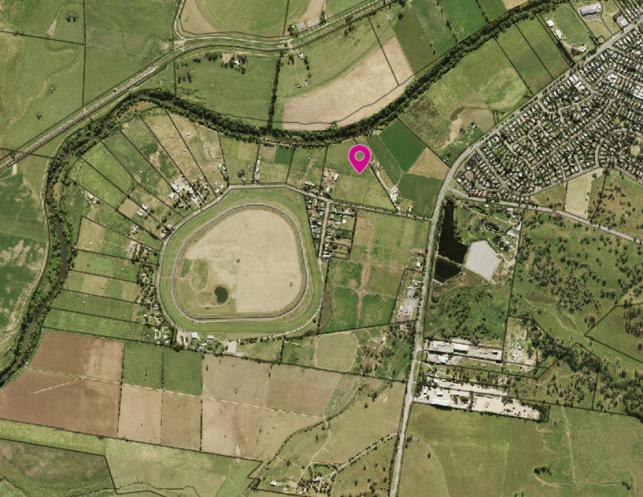

**Map 2 - Site Identification Map**

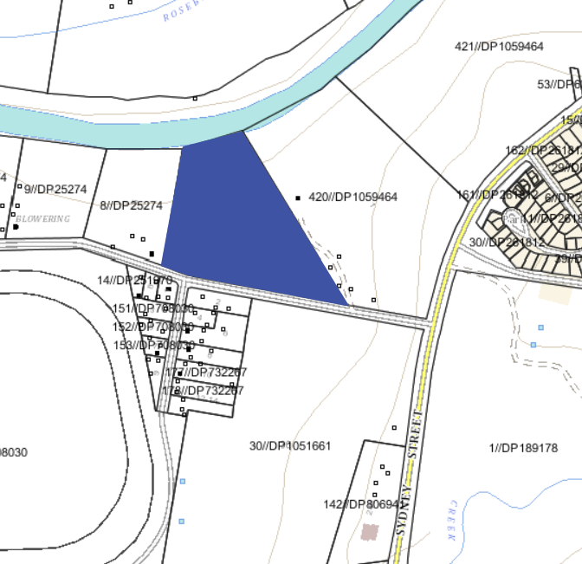

**Map 3 - Muswellbrook LEP 2009 - Land Zoning Map Sheet (LZN-008)**

## *Current Land Zoning – RU1 Primary Production*

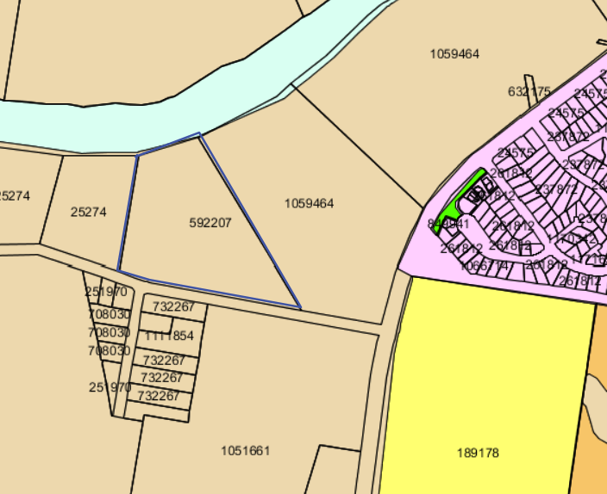

## 

**Map 4 - MLEP 2009 - Lot Size Map Sheet (LSZ-008)**

## *Current Lot Size – minimum 80ha*

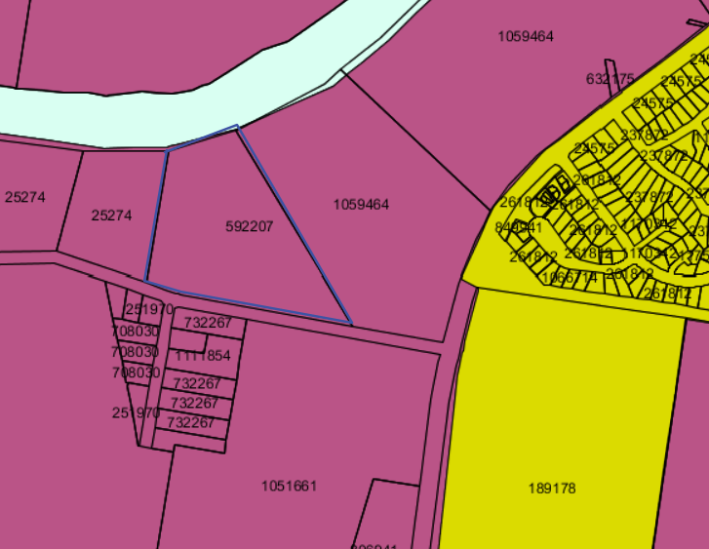

**Map 5 – Flood mapping**

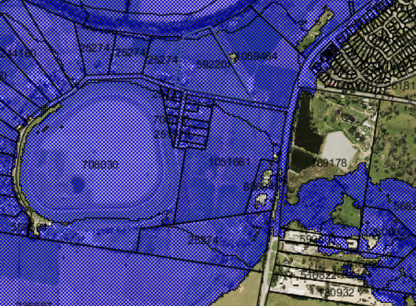

**Part 5 – COMMUNITY CONSULTATION**

A 28-day exhibition period is proposed. The Gateway Determination will confirm the exhibition period.

**Part 6 – PROJECT TIMELINE**

|  |  |
| --- | --- |
| **Action** | **Timeframe** |
| Anticipated commencement date (date of Gateway determination) | 28/08/2020 |
| Anticipated timeframe for completion of required technical information | 28/10/2020 |
| Timeframe for government agency consultation (pre exhibition) | 28/10/2020 |
| Public exhibition (commencement and completion dates) | Dependent on LEP amendment Option |
| Date of Public hearing (if required) |  |
| Consideration of submissions |  |
| Timeframe for government agency consultation (post exhibition if required) |  |
| Post exhibition planning proposal consideration / preparation |  |
| Submission to Department to finalise LEP |  |
| Date RPA will make Plan (if delegated) |  |
| Date RPA will forward to the Department for notification (if not delegated) |  |

Council intends to utilise delegations under s3.36 of the EP & A Act 1979 to finalise the Planning Proposal.

**Attachment 1**

## 

**The Business Paper and Meeting Minutes of the 12 April 1977 Denman Ordinary Council Meeting.**

**Attachment 2**

**Council letter dated 8 October 2019 advising that this land is not benefited by a ‘dwelling entitlement’.**

**Attachment 3**

**Evaluation Criteria for the Issuing of an Authorisation**

**3 Racecourse Road, Muswellbrook**

|  |  |  |  |  |
| --- | --- | --- | --- | --- |
| **Evaluation criteria for the issuing of an Authorisation** | | | | |
| **(Note – where the matter is identified as relevant and the requirement has not been met, council is to attach information to explain why the matter has not been addressed)** | **Council**  **response** | | **Department assessment** | |
| **Y/N** | **Not Relevant** | **Agree** | **Disagree** |
| Is the planning proposal consistent with the Standard Instrument Order, 2006? | Y |  |  |  |
| Does the planning proposal contain an adequate explanation of the intent, objectives, and intended outcome of the proposed amendment? | Y |  |  |  |
| Are appropriate maps included to identify the location of the site and the intent of the amendment? | Y |  |  |  |
| Does the planning proposal contain detail related to proposed consultation? | Y |  |  |  |
| Is the planning proposal compatible with an endorsed regional or sub-regional planning strategy or a local strategy endorsed by the Secretary? | Y |  |  |  |
| Does the planning proposal adequately address any consistency with all relevant S117 Planning Directions? | Y |  |  |  |
| Is the planning proposal consistent with all relevant State Environmental Planning Policies (SEPPs)? | Y |  |  |  |
| **Minor Mapping Error Amendments** | | | | |
| Does the planning proposal seek to address a minor mapping error and contain all appropriate maps that clearly identify the error and the manner in which the error will be addressed? |  | √ |  |  |
| **Heritage LEPs** | | | | |
| Does the planning proposal seek to add or remove a local heritage item and is it supported by a strategy/study endorsed by the Heritage Office? | N |  |  |  |
| Does the planning proposal include another form of endorsement or support from the Heritage Office if there is no supporting strategy/study? | N |  |  |  |
| Does the planning proposal potentially impact on an item of State Heritage Significance and if so, have the views of the Heritage Office been obtained? | N |  |  |  |
| **Reclassifications** | | | | |
| Is there an associated spot rezoning with the reclassification? |  | √ |  |  |
| If yes to the above, is the rezoning consistent with an endorsed Plan of management (POM) or strategy? |  | √ |  |  |
| Is the planning proposal proposed to rectify an anomaly in a classification? |  | √ |  |  |
| Will the planning proposal be consistent with an adopted POM or other strategy related to the site? |  | √ |  |  |
| Has Council confirmed whether there are any trusts, estates, interests, dedications, conditions, restrictions or covenants on the public land and included a copy of the title with the planning proposal? |  | √ |  |  |
| Has council confirmed that there will be no change or extinguishment of interests and that the proposal does not require the Governor’s approval? |  | √ |  |  |
| Has the council identified that it will exhibit the planning proposal in accordance with the Department’s Practice Note regarding *classification and reclassification of public land through a local environmental plan and Best Practice Guideline for LEPs and Council Land*? |  | √ |  |  |
| Has council acknowledged in its planning proposal that a Public Hearing will be required and agreed to hold one as part of its documentation? |  | √ |  |  |
| **Spot Rezonings** | | | | |
| Will the planning proposal result in a loss of development potential for the site (i.e. reduced FSR or building height) that is not supported by an endorsed strategy? | N |  |  |  |
| Is the rezoning intended to address an anomaly that has been identified following the conversion of a principal LEP into a Standard Instrument LEP format? | Partially |  |  |  |
| Will the planning proposal deal with a previously deferred matter in an existing LEP and if so, does it provide enough information to explain how the issue that lead to the deferral has been addressed? | N |  |  |  |
| If yes, does the planning proposal contain sufficient documented justification to enable the matter to proceed? |  | √ |  |  |
| Does the planning proposal create an exception to a mapped development standard? | Y |  |  |  |
| **Section 3.22 matters** | | | | |
| Does the proposed instrument   1. Correct an obvious error in the principal instrument consisting of a misdescription, the inconsistent numbering of provision, a wrong cross-reference, a spelling error, a grammatical mistake, the insertion of obviously missing words, the removal of obviously unnecessary words or a formatting error? 2. Address matter in the principal instrument that are of a consequential, transitional, machinery or other minor nature? or 3. Deal with matters that do not warrant compliance with the conditions precedent for the making of the instrument because they will not have any significant adverse impact on the environment or adjoining land?   (Note – the Minister/GSC (or Delegate) will need to form an Opinion under section 3.22 of the Act in order for a matter in this category to proceed). |  | √ |  |  |

Notes

* Where a council responds ‘yes’ or can demonstrate that the matter is ‘not relevant’, I most cases, the planning proposal will routinely be delegated to council to finalise as a matter of local planning significance.
* Endorsed strategy means a regional strategy, or any other local strategic planning document that is endorsed by the Secretary of the Department.
* Matters that will routinely delegated to a Council under administration are confirmed on the Department’s website [www.planning.nsw.gov.au/Plans-for-Your-Area/Local-Planning-and-Zoning](http://www.planning.nsw.gov.au/Plans-for-Your-Area/Local-Planning-and-Zoning/)